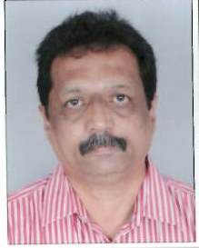

RAJATH KUMAR
Scaling new heights of success with hard work & dedication and leaving a mark of excellence on each step; targeting for senior level assignments in Automobile - Power Train - Project Management & Execution, Process design and Testing, Facility Management ,Plant Operations, with a leading organization of high repute
Industry Preference: Automobile / Heavy Machinery
rajath2011@yahoo.com
+ 9962352523/8980362626/07948909666
Personal Details  Date of Birth: 8th January, 1964  Languages Known: English, Hindi, Kannada, Marathi & Tamil  Address : C – 204 Shyam Elegance , Rahul Tower – Vastra Pur Railway Station Road , Anand Nagar, Ahmedabad- 380015 | Profile Summary
- A competent professional with experience of 22 years in project management, plant operations and manufacturing activities such as evaluation of strategic plans, process & equipment selection, capacity planning and implementation of production / process control, cost management & quality assurance to ensure top & bottom line profitability
- Ensured the timely accomplishment of production targets within given time & cost parameters; implementing cost saving measures to achieve substantial reduction in terms of man days, production cost, raw materials
- Identified areas of bottlenecks & breakdown and identifying non-conforming products; taking steps to achieve zero accident & customer complaints through the application of troubleshooting tools
- Expertise in maintaining & controlling quality standards / plans to check all manufacturing activities at the site; examining the methodology for specific operations & maintaining records as per QA norms
- Completed Green / Brown Field project with expertise in engine & gear box assembly, testing and Machining
Career Timeline
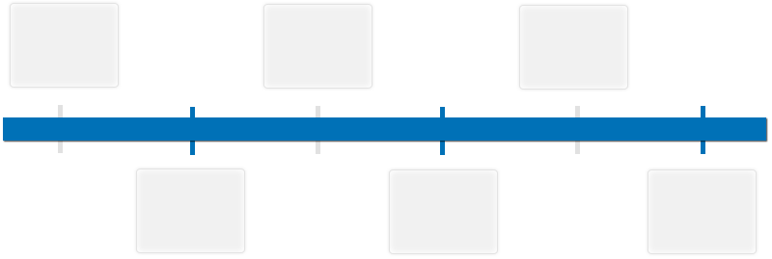
Manipal Power Press
Premier Automobile
Fiat India Automobiles Pvt. Ltd.
1992-1995
1995-1996
1996-2007
AVL India Pvt. Ltd
2007-2007
Renault Nissan Technology
Since 2014
Ford Motor Co.
2008-2014

Core Competencies
  Project Management – Green field / Brown field |  | Plant Operations
  Power Train Process & Testing |  | Capacity Building
  Vendor Management |  | Training & Development
  Facility Management
Notable Accomplishment Across Career |  | - Successfully executed low cost green field project – engine and gear box assembly, testing & housing machining line (Renault Small Car Project)  - Spearheaded installation of Engine Assembly Line (Diesel & Petrol) & 6 Engine Test Benches below the target budget (Renault Nissan)  - Bagged reduction in test cycle time by introducing Parallel Operation in Test Cycle (Renault – Nissan)  - Established Petrol & Diesel Engine Testing Process in same bench to reduce cost (Renault Nissan)  - Led the institution of the six types of engines & two type of gear box assembly line (Fiat India)  - Successfully executed Power Train Projects which includes project management and process and industrial design and facility engineering  - Conducted engine testing – performance, oil consumption and emission
Organizational Experience  Since Dec’14  Ford Motor Co., Sanand as Manager - Power Train Manufacturing Engineering (Reporting to Plant Manager)  Jan’08-Oct’14  Renault Nissan Technology and Business Centre India Pvt. Ltd., Chennai as Senior Manager – Power Train, Process / Project  Aug’07 – Dec’07  AVL India Pvt. Ltd., Gurgaon as Project Manager  Nov’96 – Aug’07  Fiat India Automobiles Pvt. Ltd., Mumbai & Ranjangaon as Asst. Manager in Production Technology Department (Engine & Gear Box) |  | Key Result Areas:  - Streamlining the entire manufacturing engineering activities of engine assembly, testing and 3 C machining , Tooling activities  - Boosting production by initiating process improvements and correct manpower planning  - Attained Cycle time reduction by rebalancing and low cost automation,  - Executed all 3 C - Tooling’s localization  - Training operator for better productivity  - Liaising with material planning department to achieve daily production and diversity control  - Resolving day-to-day quality issue through CFT approach and monitoring till closure. Leading corrective actions for internal and external customer complaints  - Implementing and engineering changes and giving feedback to engineering department  - Building new diversity in present line of products  - Supervising the operations for plant engineering activities such as utility requirement, Facility management shut down activities & new project support  - Coordinating with Finance department for Yearly budget preparation  Highlights:  - Mentored the team of 12 Engineers and effectively launched low cost engine, gear box assembly, testing and housing machining line  - Improved the process of preparing engine assembly and test parameters based on engine diversity (petrol / diesel / size of engine)  - Recognized potential manufacturing areas & improved productivity & standardized (SOPs, Time Standards, Training Records) the upgraded manufacturing set-up  - Streamlined low cost automation in the line  - Identified the suppliers for engine/gear box assembly, testing and housing machining  - Acquired technical approval of machines at the supplier’s end for supply & installation  - Conducted training for product & process, alliance quality standard & testing  Highlights:  - Conducted trials of engine test benches – both hot test benches & cold test benches  - Liaised with building team for plant set up and utility requirement  Highlights:  - Took a key role in launching six types of engines and two type of gear box assembly projects  - Governed the transferring and installation of power train line from Fiat Mumbai to Ranjangaon  - Controlled engine durability test, oil consumption test, performance test, emission test as per FIAT standard  - Effectively resolved the problems related to the engine & gear box assembly & testing line such as – process, material & tooling
Previous Experience |  | Nov’95 – Nov’96 Premier Automobiles, Mumbai as Trainee Engineer  Aug’92 – Oct’95 Manipal Power Press, Manipal, Karnataka as Production Supervisor  Aug’90 – Jul’92 Andhra Pradesh Power Tools Ltd., Bangalore as Sales Executive
Academic Details  IT Skills |  | - B.E.(Mechanical Engineering) from Mysore University, Mysore in 1990  - MS Office, AutoCAD and Internet Applications
Soft Skills |  |   Change Agent  Collaborator  Communicator  Planner  Thinker

